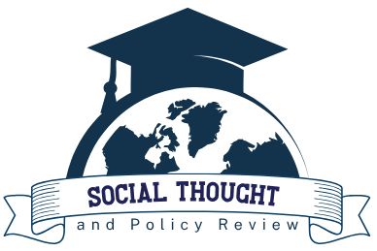
RESEARCH ARTICLE
Social Thought and Policy Review
Volume: 01 Issue: 01(2023)

POTENTIAL OF JOINT LIABILITY GROUPS (JLGS) FOR THE SUSTAINABILITY OF DAIRY INDUSTRY: CASE OF THREE CO-OPERATIVES IN KERALA
S.R. Shyam Suraj and G.R. Jayadevan
Affiliation:
Email:

Receive Date: January 26, 2023
Revise Date: March 25, 2023
Accept Date: May 13, 2023
Available Online: June 30, 2023
ABSTRACT
The milk production in Kerala is almost static for the last few years, and the major reasons for this are the increased cost of production and the reduction in the number of dairy animals. Due to scarce resources, small-scale farmers are challenged to raise funds to increase the herd size. One way to solve the problem is to mobilise resources through collaboration with community-based organisations such as Joint Liability Groups (JLGs) formed under the dairy cooperatives. The present research investigated the impact of establishing JLGs under the ambit of dairy cooperatives and providing finance for purchasing dairy animals. The case study examined three dairy cooperatives in the Wayanad district and observed a significant rise in milk procurement within the societies through the establishment of JLGs.
KEYWORDS: Milk Production; Joint Liability Group; Dairy Cooperative; Bank; Cases; Kerala

INTRODUCTION

